***Working Portal***

***User-Guide***

**Dear Tempus-ECOSTAR Partners, August 2014**

We are very pleased to share with you our TEMPUS ECOSTAR Working Platform User-Guide.The ECOSTAR - Working Platform will support us during the forthcoming 2 years project period, as a wide “content management system” with powerful platform and creative tools. It is open, accessible and shareable to many kinds of contents from all our TEMPUS partners.

The ECOSTAR - Working Platform User-Guide is a short instruction manual which aims to utilize our communication, coordination, and collaboration in an effective manner.

Thank you all for your support

**Ruthy Salomon, on behalf of Eli Shmueli, Tel Aviv University**

|  |
| --- |
| http://tempus-idea.org.il/idea_wp/wp-content/uploads/2013/04/tempus.pngThis project has been funded with support from the European Commission. This publication reflects the views only of the author, and the Commission cannot be held responsible for any use which may be made of the information contained therein. |

**The ECOSTAR - Working Platform is a friendly online collaborative system, can be used in many types of environments such as in education, training and development, and not only for academic purposes but also for bringing academic and business environments and settings.**

* 1. **Login to ECOSTAR Working Platform**

Login to ECOSTAR Working Platform with your personal username and password:

http://moodle.iucc.ac.il/ecostar/ 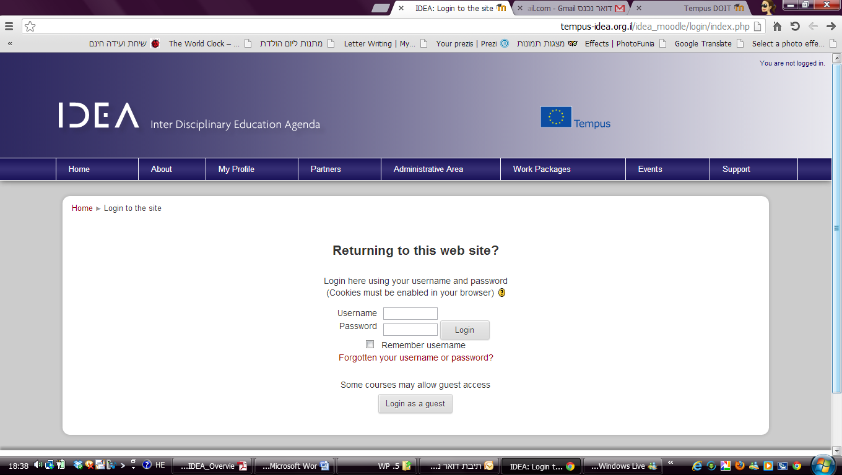

Please note – You login details are as follows

User name is the **first part of your email address – before the @**

For example **XXXXXX**@gmail.com (the red part of the email in the example is the username)   
 **Password** = 12345

`

* 1. **Personal Profile To make changes to your profile, click on the Edit profile tab:**

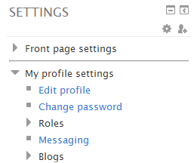

Your profile contains both required and optional fields. Required fields, which are marked with a red, include your name, email address, and location. Optional but strongly recommended items include description (a short bio) and image. You may also include a picture of yourself. This is encouraged! Upload a picture by clicking on “Add”, locating the picture file on your computer, then clicking on Open.

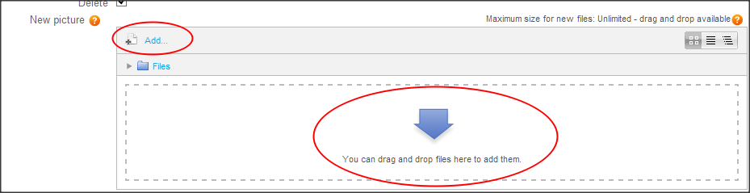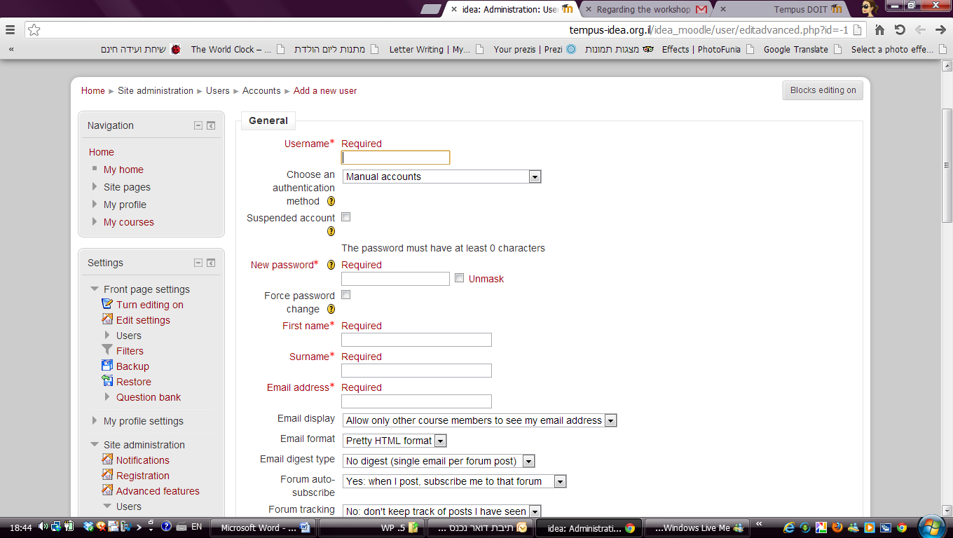Once you are done making your changes, click on "Update profile" to leave this page.

* 1. **Project Management**

All generally available areas can be accessed from a series of drop down menus on the toolbar:

To enter your work area Please click **Partners** and choose **Project Management**

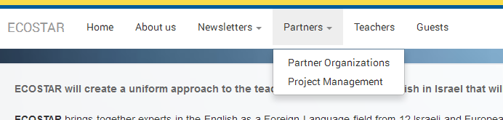

* 1. **Work Packages Structure**

Once you are inside the wanted area you will see the a list of work areas. Within your work area you invited to upload and collaborate on your content and activities.

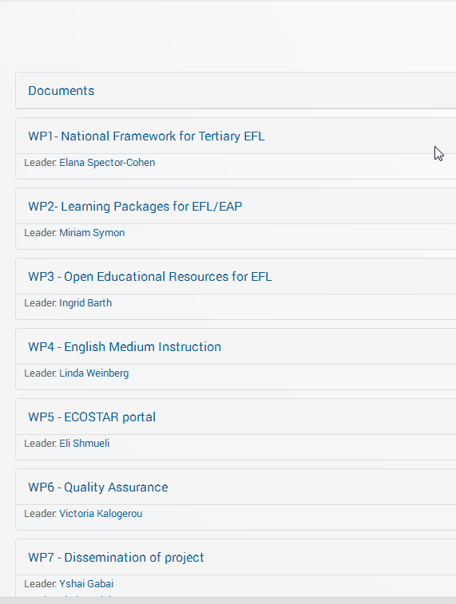

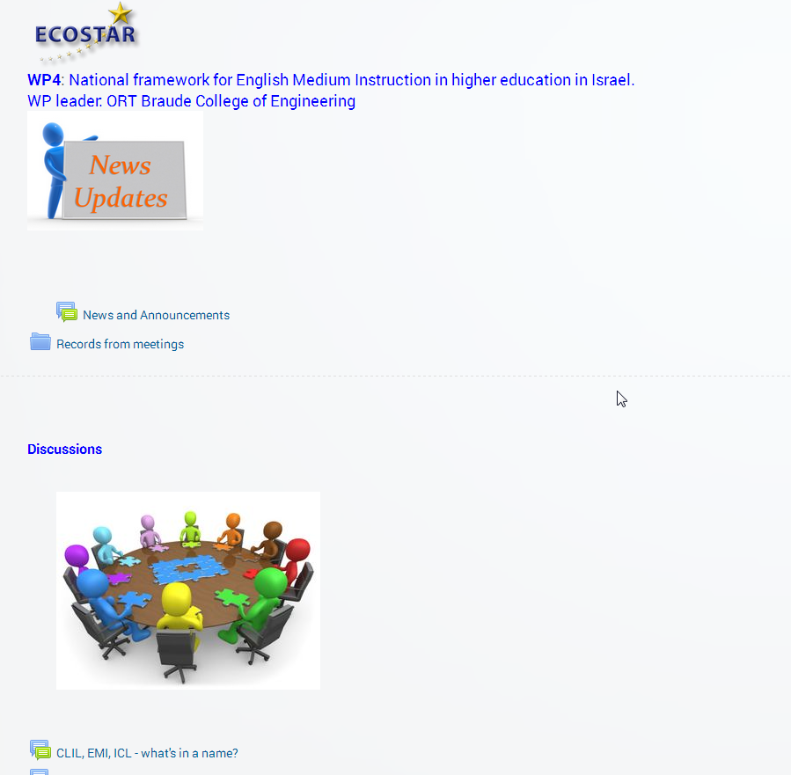

1. **Tools Guide**

The following tools available to you in your project working space :

* 1. **Files Storage** - Virtually any digital documents, images, audio/video, and text files. When you wish to share with your partners a simple file such as a Word-processed document or slideshow (for example created in MS-Word, PowerPoint, or Open Office) you use the File resource type. It allows you to upload and display a variety of resources on your course:

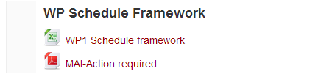

* + 1. **Folders -** A folder allows displaying several files together. The resources may be of different types and they may be uploaded by different partner.
    2. **Labels -** A label serves as a spacer on a main page. It can be used to add text, images, multimedia or code in between other files in the different sections: 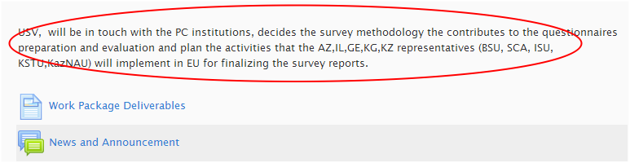
    3. 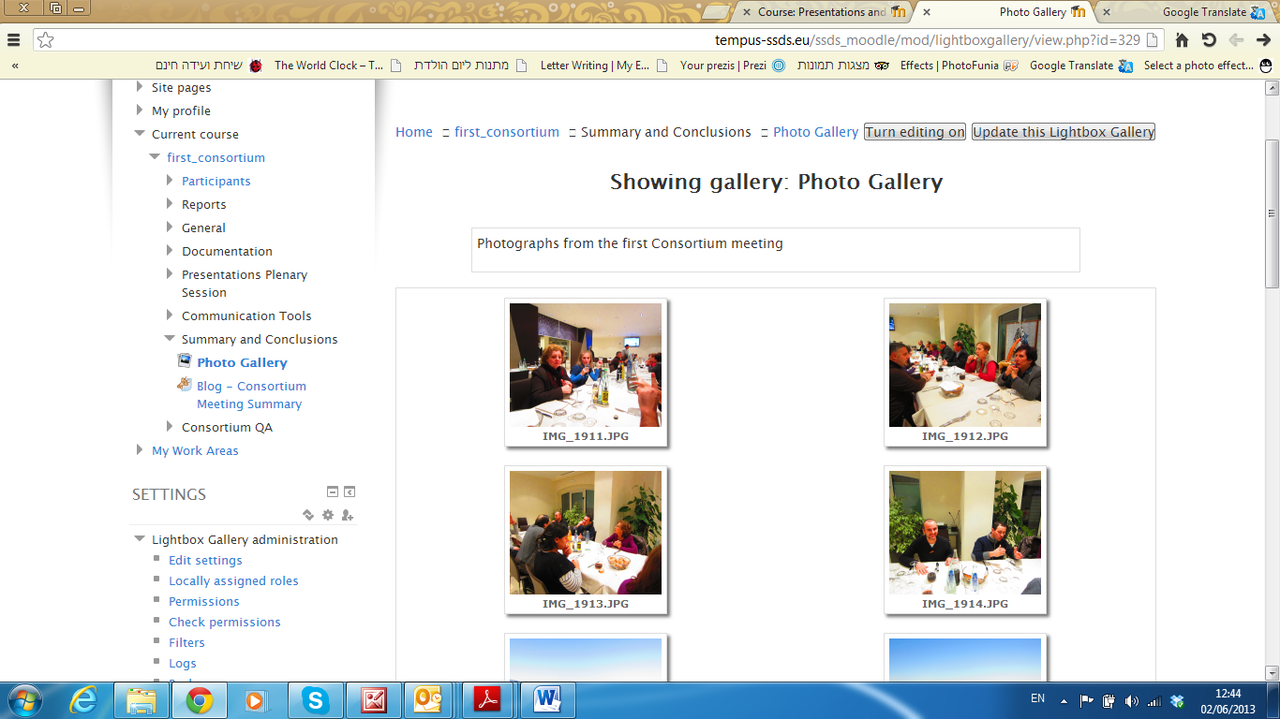**Lightbox Gallery** - This resource allows you to create image galleries:
    4. **Page -** A page resource creates a link to a screen that displays the content created by partners. The robust Text editor allows the page to display many different kinds of content. In certain cases it might be preferable to use the page resource instead of uploading a word-processed document, particularly if the document contains text that is just to be read and not downloaded.
  1. **Communication tools**
     1. **Forums -** The forum module is an activity where partners can exchange ideas by posting comments. The forum participants will receive notifications to their email. A forum can contribute significantly to successful communication and community building in an online environment. **The copy of each message will be sending to partner’s email address.**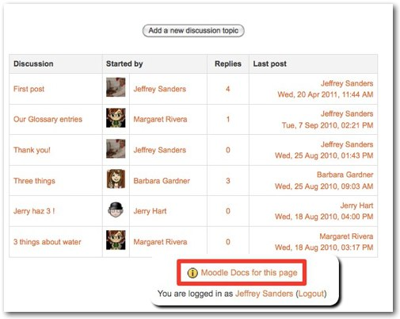
     2. **Messaging** – Allows sending messages to individual. The copy of each message will be sending to partner’s email address.
     3. 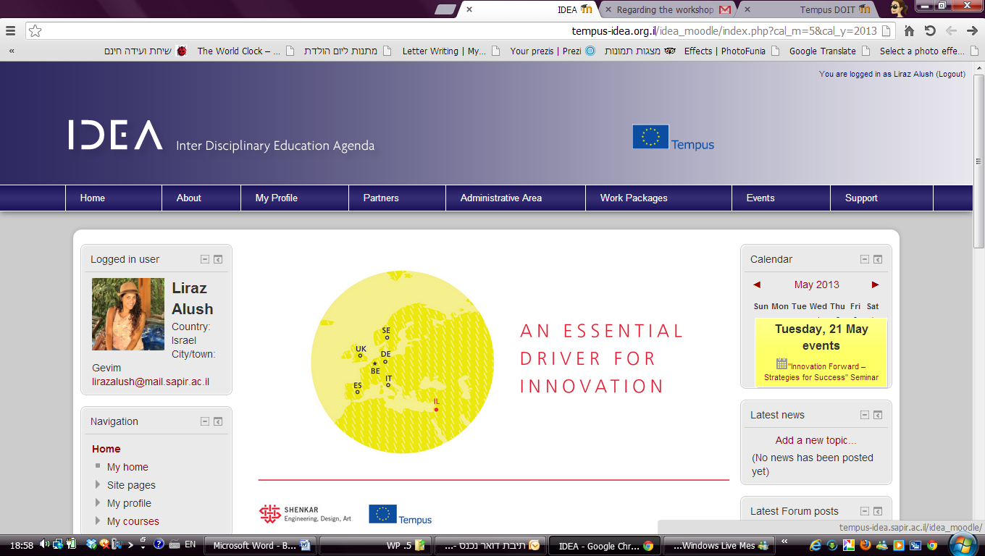**Calendar -** The calendar will display ECOSTAR project’s events.
  2. **Collaboration tools**
     1. **Blog** - Allows partners to reflect on a particular topic.
     2. **Glossary** - The glossary allows participants to create and maintain a list of definitions, like a dictionary. Glossary can be used in many ways. The entries can be searched or browsed in different formats. A glossary can be a collaborative activity or be restricted to entries made by the leader. Entries can be put in categories and will be organized alphabetically.
     3. **Database** - The database activity module allows the partners to build, display and search a bank of record entries about any conceivable topic. The format and structure of these entries can be almost unlimited, including images, files, URLs, numbers and text amongst other things: 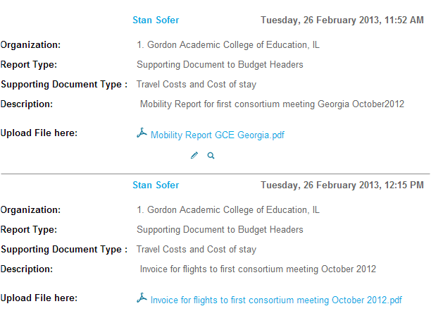
     4. **Wiki** - A wiki is a collection of collaboratively authored web documents. Basically, a wiki page is a web page everyone in your team can create together, right in the browser.
     5. **Workshop** - Workshop is a peer assessment activity with many options. Students submit their work via an on line text tool and attachments. There are two grades for a student: their own work and their peer assessments of other students' work.
     6. 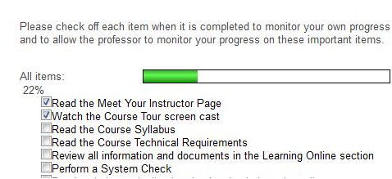**Checklist -** Allows a Leader to create a checklist for the Members to work through. The Members should tick off each item on the list, as they complete it and the resulting progress of the team can be monitored by the Leader. The progress bar shows how far through the checklist they have managed to get.

* 1. **Evaluation tools**
     1. **Questionnaire -** Allows you to create and conduct surveys to collect feedback. The Questionnaire activity is ideal for evaluations.

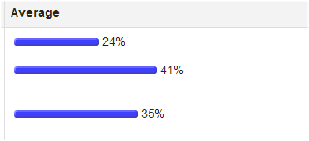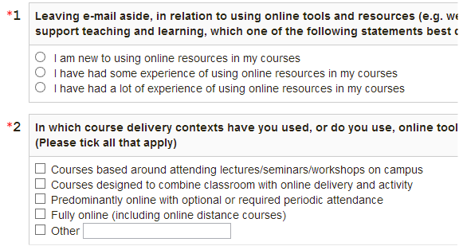

* + 1. **Choice -** A choice activity is very simple – the Leader asks a question and specifies a choice of multiple responses. It can be useful as a quick poll to stimulate thinking about a topic; to allow the team to vote and to gather research consent.

[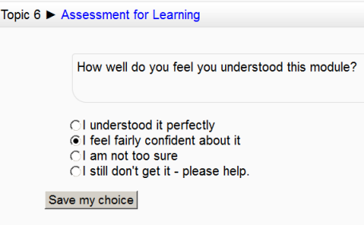](http://docs.moodle.org/20/en/File:Choiceexample.png)

# System Requirements

**3.1**   **Internet Connection**

A minimum of 56k dial up. Moodle recommends DSL or Cable internet connections for best performance.

**8.2 Display**

1024 x 768 or higher is recommended when applicable.

Modern [browsers](http://en.wikipedia.org/wiki/Web_browser) are considered to be browsers that support the [HTML5](http://en.wikipedia.org/wiki/HTML5) and [W3C](http://en.wikipedia.org/wiki/World_Wide_Web_Consortium) standards which provide rich Internet surfing and browsing experience that includes: Speed, Functionality and Safety.

**Modern Browser**

Tempus-ECOSTAR Working Platform will work in any modern web browser; however, it works best in a range of modern browser types (see below). Your browser should also have both cookies and JavaScript enabled.

**We recommend one of the following modern browsers:** [**Firefox**](http://www.mozilla.com/en-US/firefox/new/)**,**[**Chrome**](http://www.google.com/chrome)**:**

|  |  |  |
| --- | --- | --- |
| [get-chrome](http://www.google.com/chrome) | [GetFirefox](http://www.mozilla.org/en-US/firefox/new/) |  |

**Is my browser Moodle ready?**[**(special link to automatically Check it)**](http://moodle.uvic.ca/file.php/1/detect/index.htm)

**Modern browsers enable:**

* Advanced and sophisticated website design, enhanced Multimedia - Video, Audio, Animation, 2D, 3D and Image display.
* Extend browser functionality with plugins
* Provide faster (300% to 1200%) website browsing performance improvements when comparing to older browsers. ie. IE6/IE7/IE8.
* Uses fraction of your RAM, up to 1/3 of older browsers.
* Safety due to sandbox technologies and updated code.